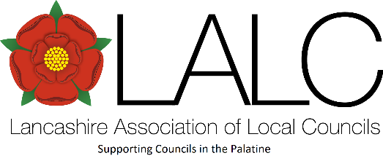
Long Service Awards Scheme
There are Councillors, Clerks and officers out there who have been working and serving their communities for many years.
There are of examples of 25 years, to over 50 years service…
LALC is to kick-start a new Long Service Awards scheme and would like to know about your long-serving person.
The awards will be presented at the Annual meeting of LALC, or passed on if recipients are unable to attend.


Considerations for an award are:
- Should be awarded in recognition of contribution and length of service to the community over a prolonged period of time
- Nominations to be initially over service levels of 25 years and in increments of 5 eg, 25, 30, 35 etc.
- Can be awarded to any Councillor or Council officer, who renders an identifiable and consistent contribution to their Council.
- Can be proposed by a LALC member Council/officer.
- LALC Executive sub-committee will have absolute discretion regarding who receives an award.
- It is not necessary to award if no-one is proposed and it is not a requirement that every nomination is awarded even if proposed.
This is an award, solely in the gift of LALC and confers no material honours or special privileges nor does it entitle the person to participate in the proceedings or in any ceremonial events. It is purely and simply awarded to recognise the achievement of long service of the recipient.
Anyone wishing to nominate should initially fill in the form in conjunction with the selection considerations above.

Nomination form for a LALC Long Service Award

All fields should be completed.

Details of person nominated
Full name
Council name
Position: Councillor or other, please specify
Years of service: start dates of, gaps in service etc
Is the nominated person due to leave soon or has left recently, please specify
Reason for nomination
Please explain in approx 500 words the contribution your nominee has made to your Council, or area, project etc…
Reference
References from others familiar with the work of the nominee are required, these can be attached to this form or, alternatively can emailed to office@lalc.org.uk quoting this Long Service application.
Does the nominee(s) know you are nominating them for this scheme?  If ticked no, do you acknowledge that, at some point, it will be necessary to contact the nominee(s) to get their agreement for the nomination to progress? |  | Yes No  Yes No

Details of nominator
Full name
Council name
Address
Town/city
Postcode
Telephone number
Daytime telephone
Email address
Please explain your relationship/connection to the nominee:

LALC will use your information in order to process your nomination in a manner compatible with the Data Protection Act. Any disclosures or sharing of information will only take place where required or permitted by law to carry out this process for which you have supplied this information.
If you have any queries about this form please contact the 01772 750900 or office@lalc.org.uk
Send completed forms to office@lalc.org.uk entitled: Long Service Award nomination.

